Please put in your code for the questions that are applicable.

1. In your own words describe what is a pointer

A pointer is a variable that stores the address of another variable.

For example-

Int *ptr; //declare pointer variable

Int var = 10; // declare integer value

p = &var;

P now contains the value of the address of the var variable.

1. Which of the following in C++ is a pointer
   1. int r, j;
   2. char *options;
   3. float &pathogens;

b

int menu = 23;

1. Print out the value of menu

Cout << menu;

1. Print out the address of menu

Cout << &menu;

int *menu_pointer = &menu;

1. Print out the value of menu using menu_pointer.

Cout << *menu_pointer (dereferenced menu_pointer)

1. Print out the address of menu using menu_pointer.

Cout << menu_pointer

1. Print out the value in menu_pointer.

Cout << *menu_pointer (dereferenced menu_pointer)

1. Print out the address of menu_pointer.

Cout << &menu_pointer

1. Change the value in menu using menu_pointer.

*menu_pointer = 12;

3. Write an expression to calculate the address of the variable testvar.

int testvar;

int *ptr;

ptr = &testvar;

cout << ptr << endl;

4. Define a variable named char_pointer whose data type is a pointer to a char.

Char *char_pointer;

5. Create a class with the name of ‘cat’ that contains a pointer to another ‘cat’

Class cat{

cat* felix;

Cat : felix(nullptr) {};

};

6. In your own words tell me why a pointer is important.

Pointers are useful for many different reasons. Perhaps you want to return multiple values from a function. They decrease execution time and memory footprint within a program and create a dynamically. They can also make variables useable throughout a program.

7. Write a function that increments the parameter by 2 permanently and returns nothing (void). After calling said function print out the variable you passed to the function in main and show that the function changed the value of the variable.

#include <iostream>

using namespace std;

void incByTwo(int &number)

{

number += 2;

}

int main()

{

int number = 5;

incByTwo(number);

cout << number;

}

8. 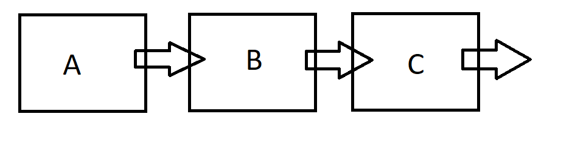  
  
 What does A point to?

B

What does B point to?

C

What does C point to?

Null